JOB MARKET ANALYSIS - INSIGHTS

EXECUTIVE SUMMARY

1. Introduction
The Job Market Analysis project focuses on understanding the current demand for data-related job roles, required technical skills, salary patterns, industry distribution and geographical concentration of job opportunities.
After the data cleaning process, the final dataset contains 742 job postings across 41 features. SQL and Python were used to analyze the dataset and identify important patterns related to job titles, salaries, companies, industries, locations, education and technical skills.

2. Overall Job Market Findings
The overall average salary in the dataset is 101.48K, while the average company rating is 3.69. The average company age is approximately 51 years, indicating that the dataset contains opportunities from a mix of established organizations.
The analysis shows that Data Scientist is the most common job title in the dataset, with 131 postings. This indicates strong demand for professionals with data science and analytical capabilities.
Among industries, Insurance Carriers has the highest number of data-related job postings. Geographically, California (CA) has the highest concentration of job opportunities with 152 postings.
Takeda Pharmaceuticals, MassMutual and Reynolds American are tied as the companies with the highest number of job openings in the analyzed dataset, each with 14 postings.

3. Overall Insight
The overall analysis indicates that the data-related job market provides opportunities across multiple industries and locations, with particularly strong demand for Data Scientist and other technical data roles.

JOB MARKET & INDUSTRY INSIGHTS

1. Job Title Demand
The job-title analysis shows that Data Scientist is the most frequently occurring job category in the dataset, followed by Data Engineer, Senior Data Scientist and Data Analyst.
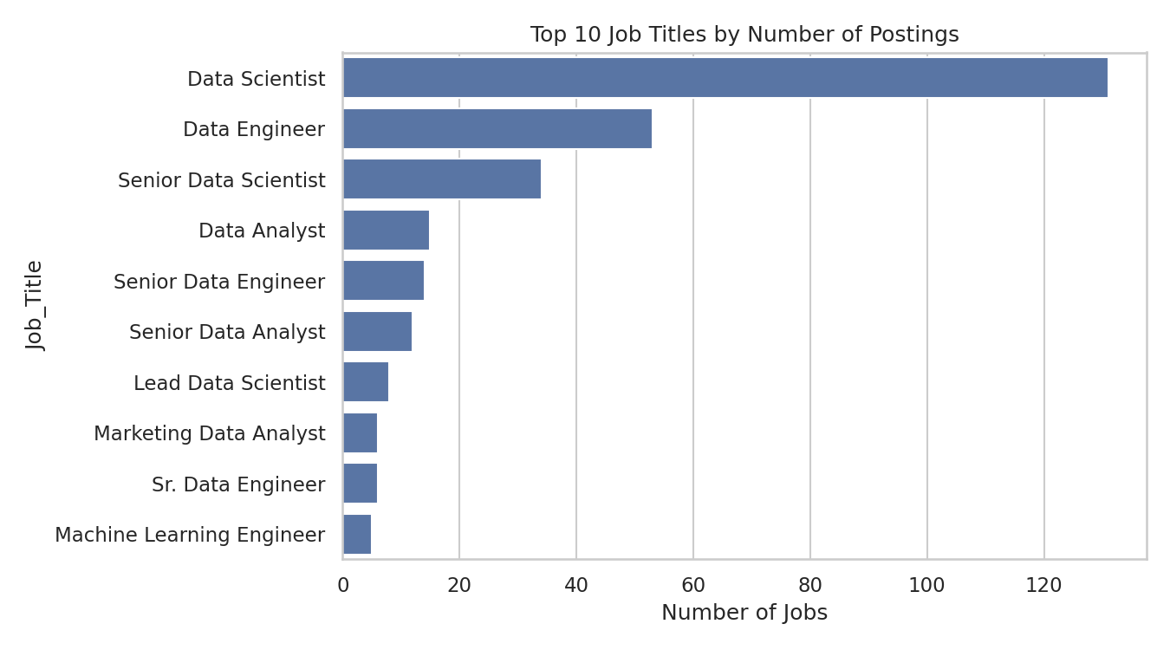
Figure 1: Top 10 job titles by number of postings
This indicates that organizations are hiring for a broad range of data-related positions rather than focusing on a single specialization.
Key Insight: The high number of Data Scientist postings suggests that data science remains one of the major areas of employment within the analyzed job market.

2. Industry Insights
Insurance Carriers is the leading industry by number of data-related job postings, followed by Computer Hardware & Software and Biotech & Pharmaceuticals.
This suggests that industries involving finance, technology, and scientific research have substantial requirements for professionals capable of working with data.
Key Insight: The presence of data-related roles across multiple industries demonstrates that data skills are not limited to technology companies and are increasingly relevant to domain-specific organizations.

3. Location Insights
The analysis shows that California (CA) has the highest number of job postings among the locations in the dataset, followed by Massachusetts (MA) and New York (NY).
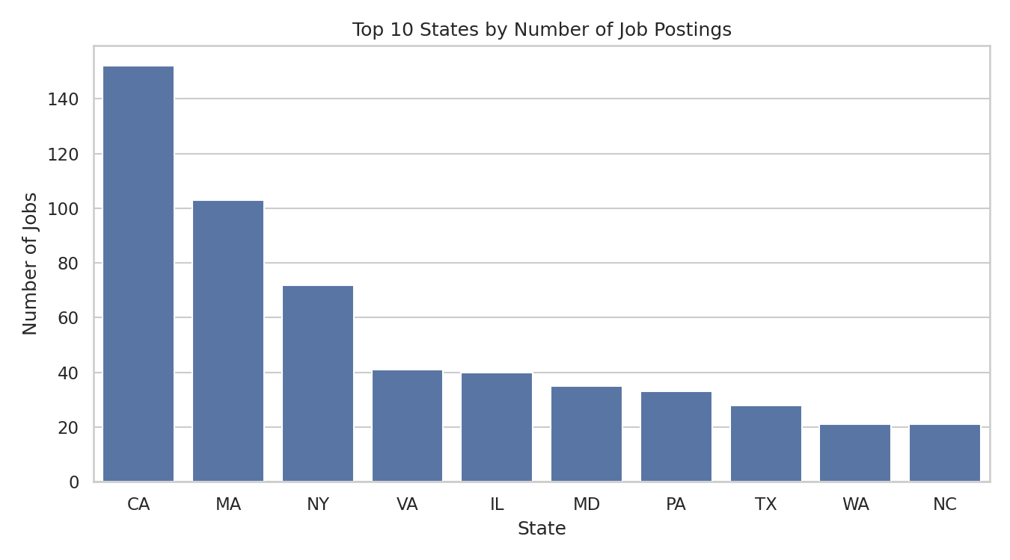
Figure 2: Top 10 states by number of job postings
This indicates a strong geographical concentration of data-related employment opportunities in California.
Key Insight: Job seekers may find a larger number of opportunities in locations with strong technology, healthcare, scientific and business ecosystems.

4. Company Insights
Takeda Pharmaceuticals, MassMutual and Reynolds American have the highest number of job openings among the companies represented in the dataset, each with 14 postings.
This demonstrates that some organizations contribute significantly more job postings than others and may have broader requirements for data-related professionals.

Overall Job Market Insight
The job market is concentrated around a combination of high-demand job roles, specific industries and major employment locations. Data Scientist positions, California-based opportunities and organizations such as Takeda Pharmaceuticals and MassMutual represent important areas of concentration in this dataset.

COMPANY & FEATURE INSIGHTS
Beyond the core SQL queries, the remaining dataset features were explored in Python to check for additional patterns in ratings, company size, age, revenue and pay structure.

1. Company Rating Distribution
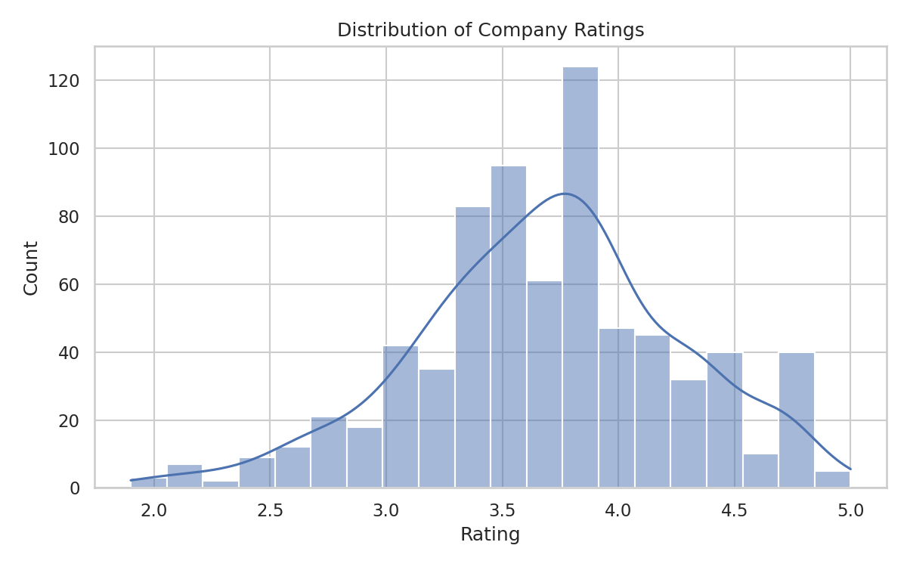
Figure 3: Distribution of company ratings
Most companies in the dataset cluster around a rating of 3.0 to 4.0, with relatively few companies rated below 2.5 or above 4.5.

2. Company Size vs. Salary
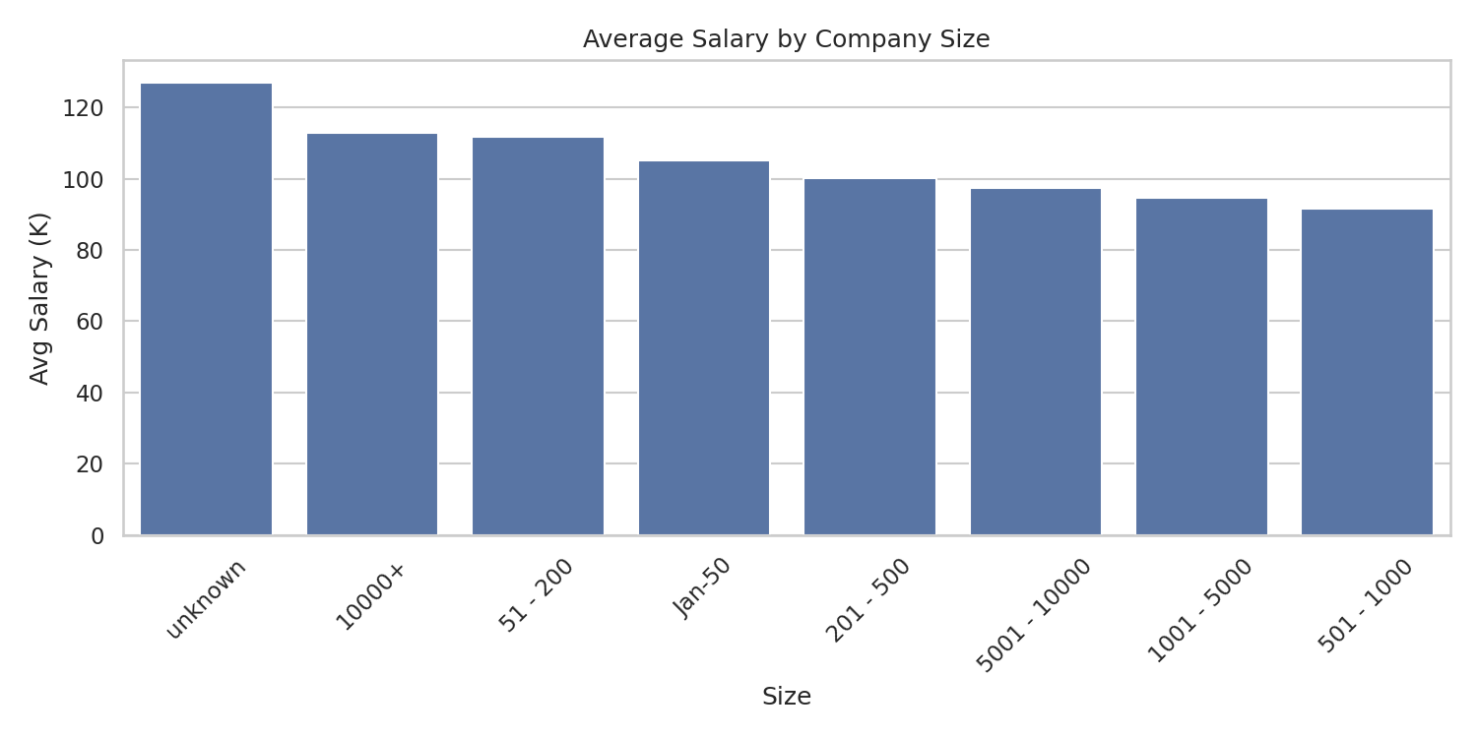
Figure 4: Average salary by company size
Average salary does not increase in a straightforward way with company size; some mid-sized companies pay comparably to or more than the largest ones.

3. Company Age vs. Salary
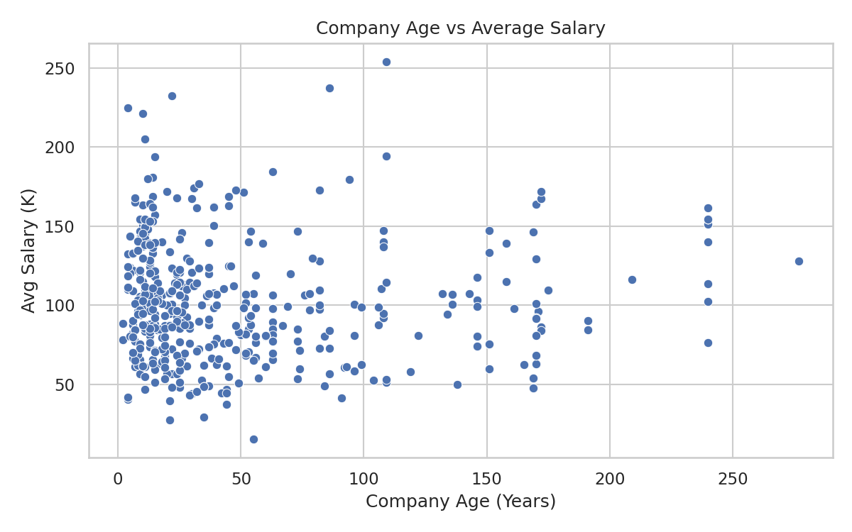
Figure 5: Company age vs. average salary
There is no strong visible relationship between how long a company has existed and the salary it offers, suggesting company age is not a major salary driver in this dataset.

4. Revenue Distribution
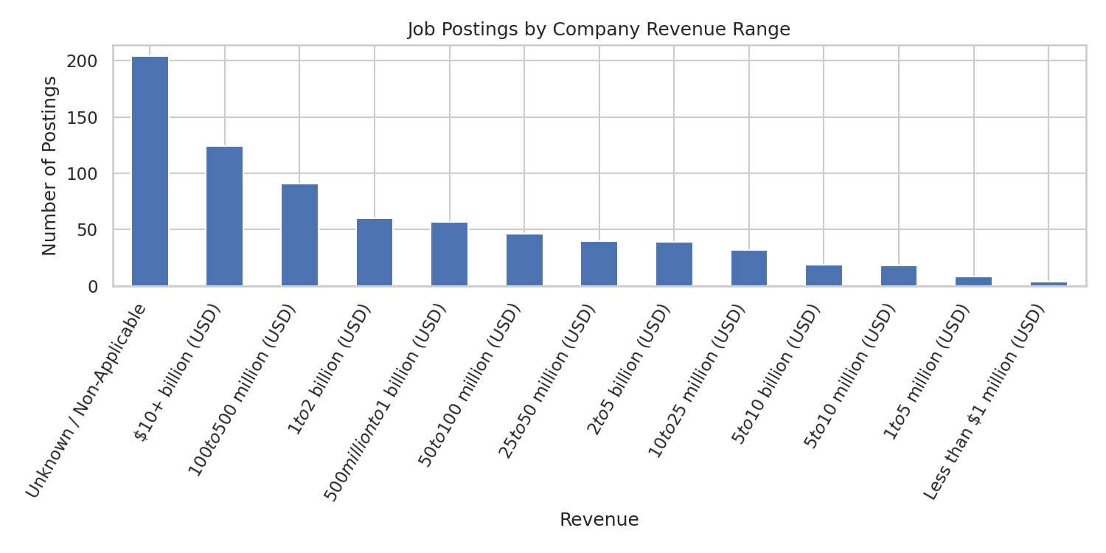
Figure 6: Job postings by company revenue range
A large share of postings come from companies with revenue that is unknown or non-applicable, followed by large, well-established companies with revenue above $10 billion.

5. Hourly and Employer-Provided Salary Flags
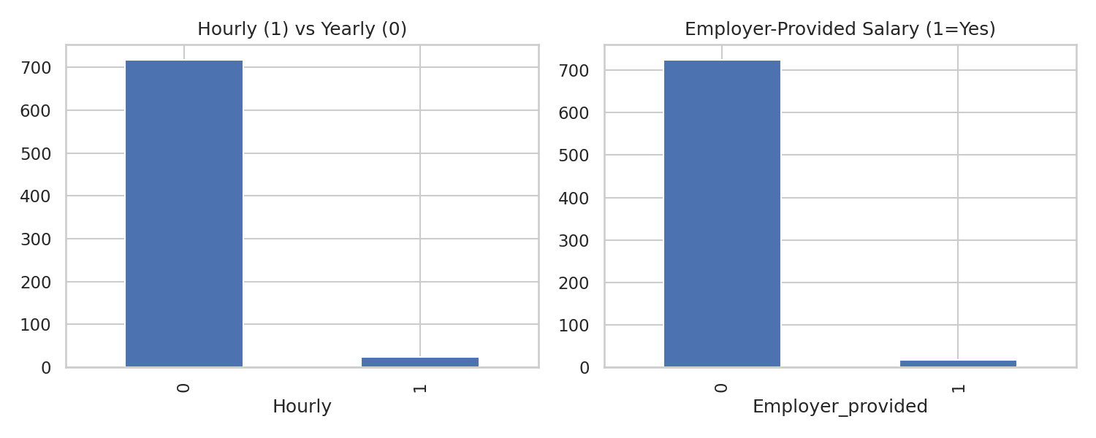
Figure 7: Hourly vs. yearly pay, and employer-provided vs. estimated salary
Only 24 of 742 postings (3.2%) report hourly rather than annual pay, and only 17 postings (2.3%) have employer-provided salary estimates.
Key Insight: The dataset is overwhelmingly salaried, and most salary figures come from third-party estimates rather than the employer directly, which is worth noting as a data-quality caveat.

SALARY INSIGHTS

1. Overall Salary
The average salary across the cleaned dataset is 101.48K.
This provides a useful benchmark for comparing salary differences across job titles, education levels and other job characteristics.

2. Education and Salary Relationship
The analysis of salary by education category produced the following results: PhD-requiring postings average 115.98K, Master's-requiring postings average 105.63K, and postings with no degree specified average 94.70K.
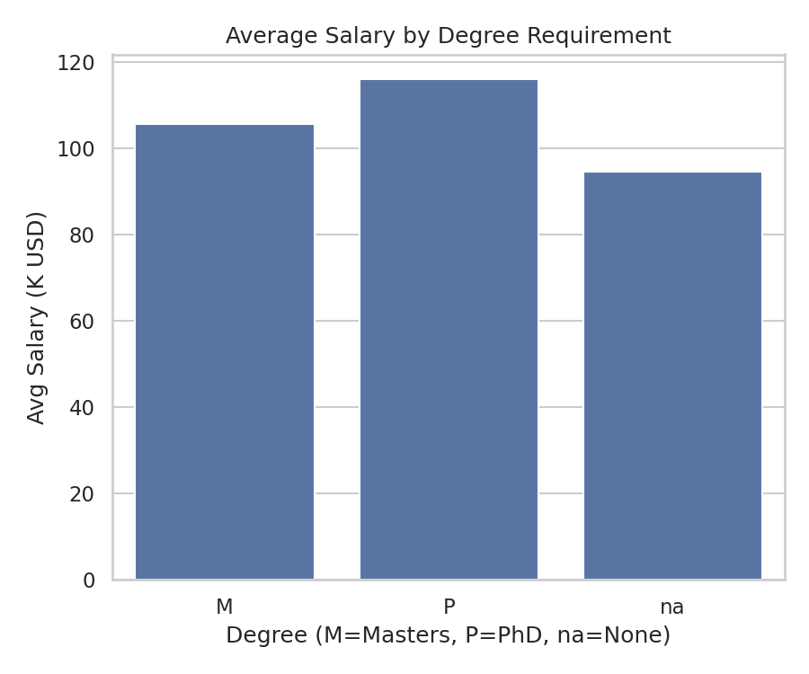
Figure 8: Average salary by degree requirement (M = Master's, P = PhD, na = none specified)
The difference between the highest and lowest education categories is 21.28K.
Key Insight: The PhD category has a higher average salary than the Master's and no-degree categories, suggesting that advanced education is associated with higher-paying roles in this dataset.

3. Salary by Seniority
Senior-level postings average 121.69K, compared to 93.10K for postings with no seniority indicator and 71.00K for junior-level postings.
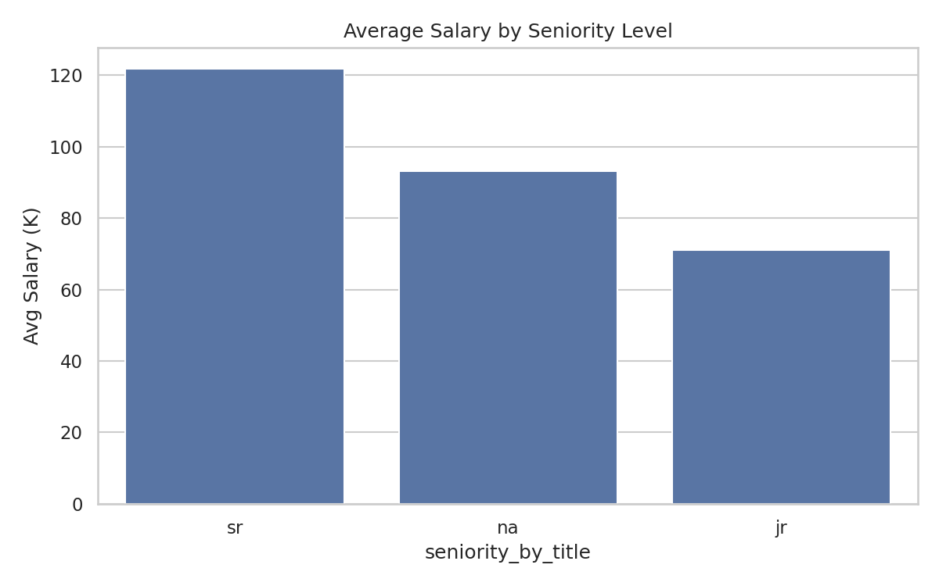
Figure 9: Average salary by seniority level
Key Insight: Seniority has a clear and substantial effect on salary, with senior roles paying roughly 31% more than roles with no seniority indicator.

4. Salary by Company Ownership
Publicly traded companies and business-segment subsidiaries offer the highest average salaries (111.04K and 110.57K respectively), while hospitals and nonprofit organizations offer the lowest (66.83K and 73.19K respectively).
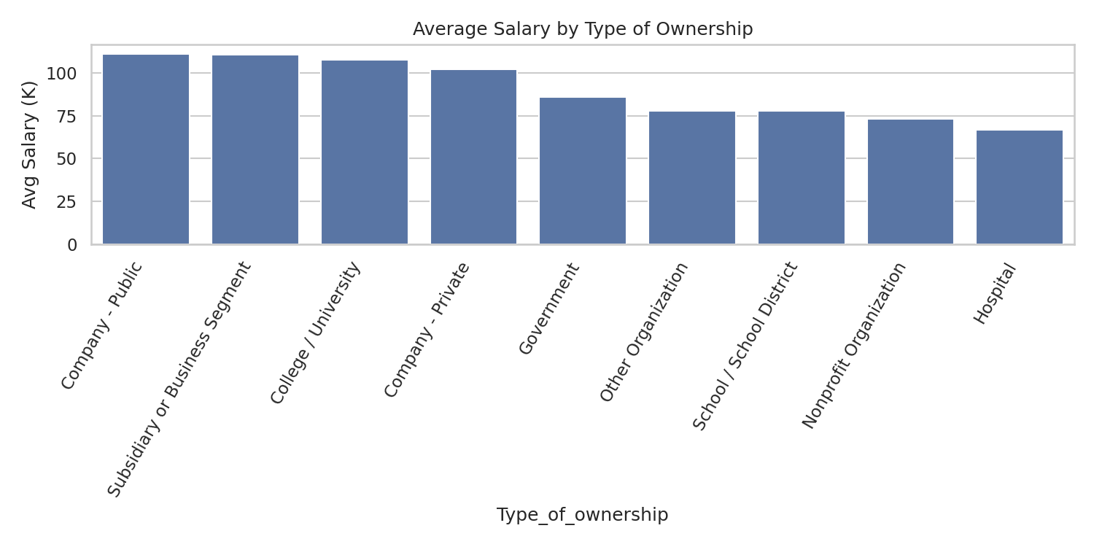
Figure 10: Average salary by type of ownership

5. Salary by Location
California has both the highest job volume and the highest average salary (123.51K), followed by Illinois (116.66K) and Massachusetts (107.50K).
Key Insight: High-opportunity states also tend to offer higher average compensation, reinforcing California's position as the most attractive market for data-related roles.
SKILLS INSIGHTS

1. Most In-Demand Skills
Python is the most frequently required skill, appearing in 392 of 742 postings (52.8%), followed closely by Excel (388 postings, 52.3%) and SQL (380 postings, 51.2%).
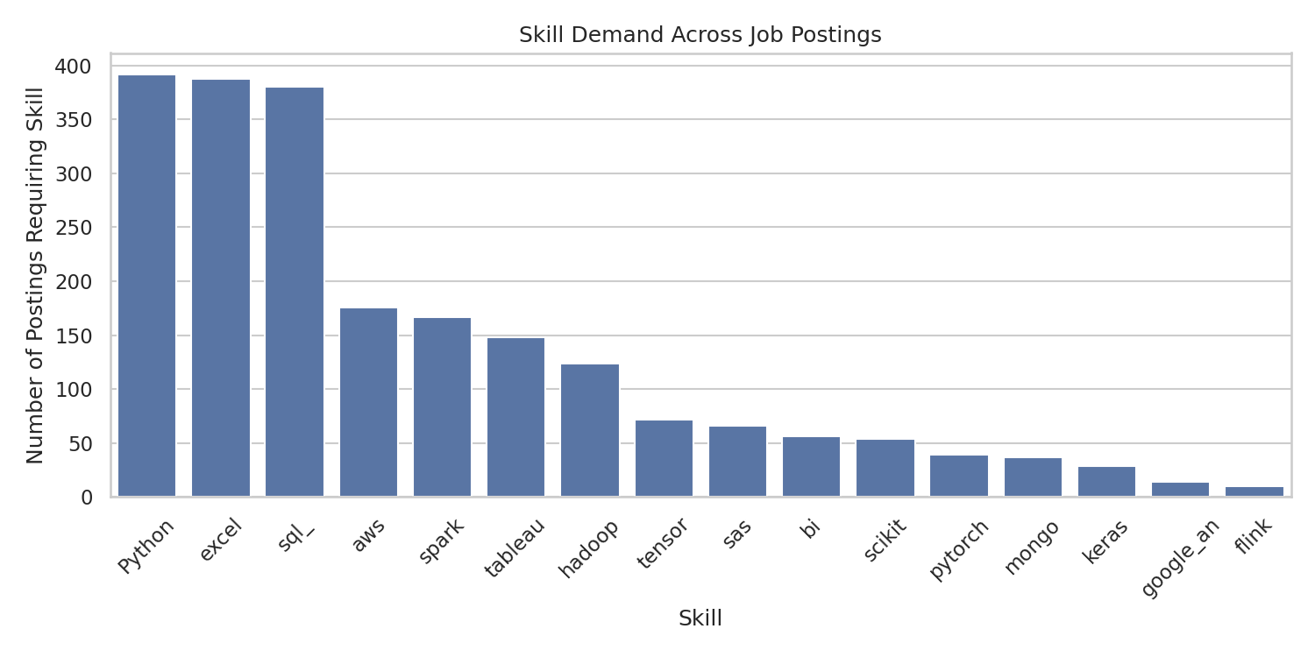
Figure 11: Skill demand across job postings
Cloud and big-data skills such as AWS (176 postings) and Spark (167 postings) form a second tier of demand, along with visualization tools like Tableau (148 postings).
Key Insight: Python, Excel and SQL form the core baseline skill set expected across the majority of data-related job postings.

2. Skills Associated with Higher Salary
Although Python, Excel and SQL are similarly in demand, they are not equally rewarded. Python shows the strongest positive correlation with salary (+0.32), followed by Scikit-learn (+0.18), AWS (+0.17) and Spark (+0.17).
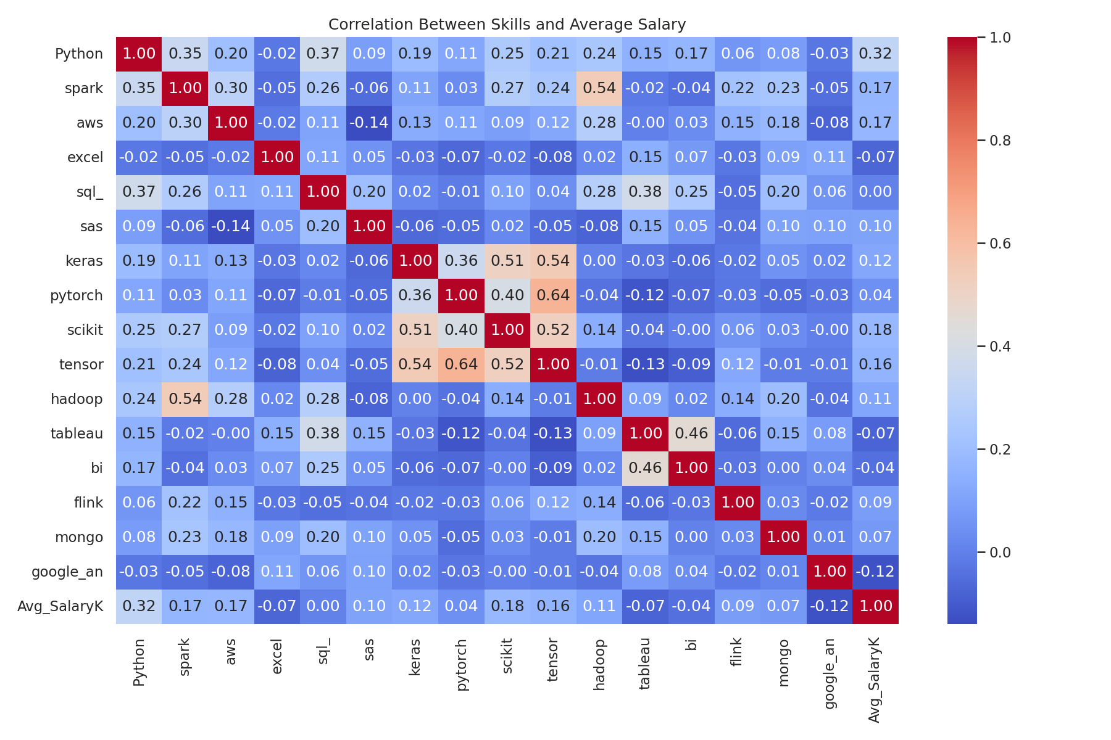
Figure 12: Correlation heatmap between skills and average salary
By contrast, Excel (-0.07), Tableau (-0.07) and Google Analytics (-0.12) show a slight negative correlation with salary, and SQL shows almost no correlation (+0.002).
Key Insight: Demand and pay are not the same thing. Programming and machine-learning skills (Python, Scikit-learn, AWS, Spark) are associated with higher-paying roles, while spreadsheet and visualization tools are more common in lower-paying analyst-track roles.

DATA QUALITY NOTES
Before analysis, the dataset required cleaning: a fully empty column (FIELD4) was removed, and placeholder values of -1 in Founded, Age and Rating were converted to missing values rather than treated as real numbers. Competitors data was missing for 62% of postings and was converted into a Yes/No flag rather than imputed.
Only 24 postings (3.2%) report hourly rather than annual pay, and only 17 postings (2.3%) have employer-provided salary estimates, meaning most salary figures in this dataset come from third-party estimates.

CONCLUSION
The data-related job market represented in this dataset is concentrated in California and a small number of high-volume states, dominated by Data Scientist and Data Engineer roles, and spread across both technology and non-technology industries such as Insurance and Biotech. Salary is most strongly influenced by seniority, education level, and the specific technical skills required, with Python standing out as the skill most associated with higher pay.

